User interface design

for iOS, using Objective-C

# Lab 3 – Making an iPad App

## Functional Goals

Take a functional iOS app that contains the necessary controls to display bandwidth usage data from Rose-Hulman’s network usage tool and add asynchronous data connections.

## Learning Goals

* Understand iOS paradigms, including creating an iPad app from a previously created iPhone/iPod Touch app.

## Prerequisites

* You’ll need to install Xcode (Version 4.5.2 was used to create this lab) from the App Store
* A basic understanding of Xcode and Objective C development
* Code from Lab 2 (a complete version may be available from your instructor)

## Submission Instructions

Submit answers to the **3** (or **4**, with extra credit)questions in this lab as a .pdf to the appropriate Moodle submission form.

## Move your views over to the iPad Storyboard

You are about to see how amazingly easy it is to create a working iPad application from an existing iPhone/iPod Touch application. Go to the MainStoryBoard_iPhone.storyboard file. Using cmd-a, select all of the items in the iPhone storyboard. Using cmd-c, copy all of the UI elements. Now select your MainStoryBoard_iPad.storyboard file. Use cmd-v to paste the views into the iPad storyboard. You may have to move them around slightly as they often stack when initially copied over.

You may also notice a need to tweak the sizes of certain interface items, but the majority of your views will be copied over just like you want them. Since we are replacing the automatically created views with our new ones, you’ll see the old ones are still there. Uh-oh!

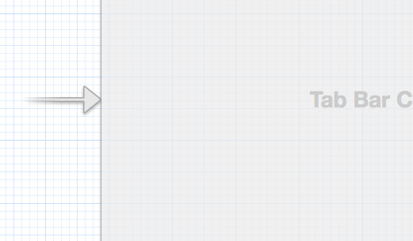

First we need to grab the arrow that indicates that a view is the initial view to be launched when the app starts and move it over to our new initial view we just pasted in. You can do this by clicking and dragging or by going to the Attributes Inspector and selecting “Is Initial View Controller”:

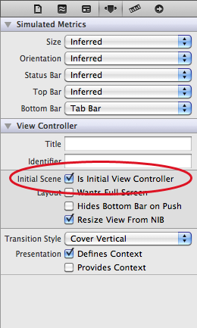

Your file should look like this:

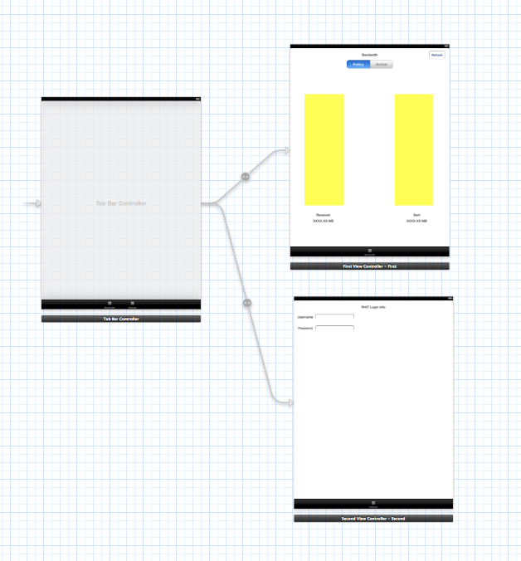

Finally, delete the auto-generated views that simply say FirstViewController and SecondViewController as well as their containing TabBarController view. Run the application for iPad now. Your app should work completely!

*Note: Sometimes Xcode has trouble keeping the connections to the ViewControllers, so if you’re having trouble check the connections between interface builder and your viewcontroller first!*